Sample Database Operations

1. Click on file and select "New"=> "Application"

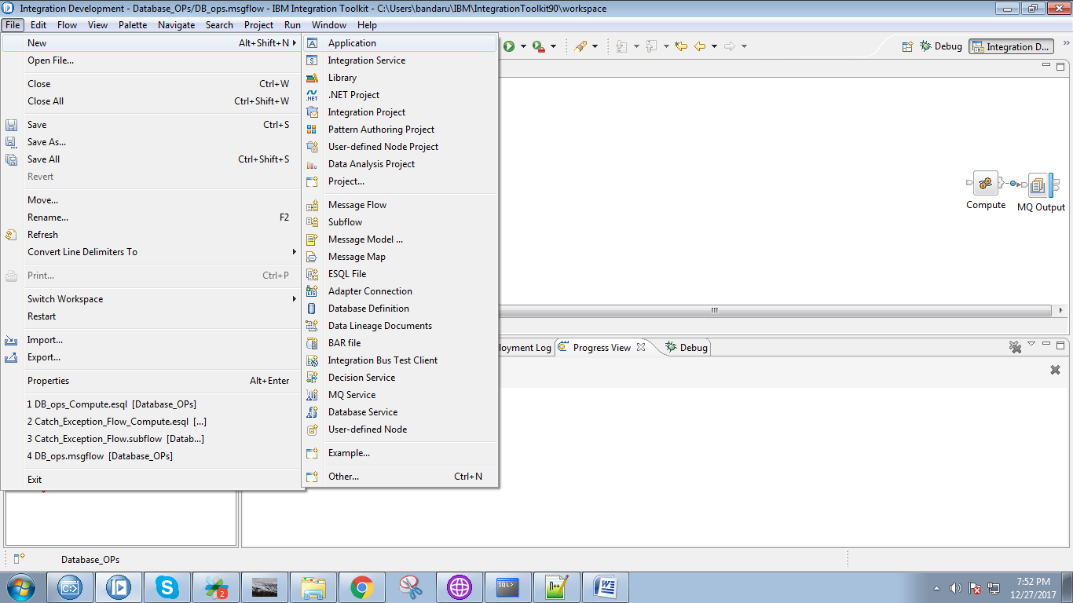

2. Give a name for your application and click on "Finish" button.

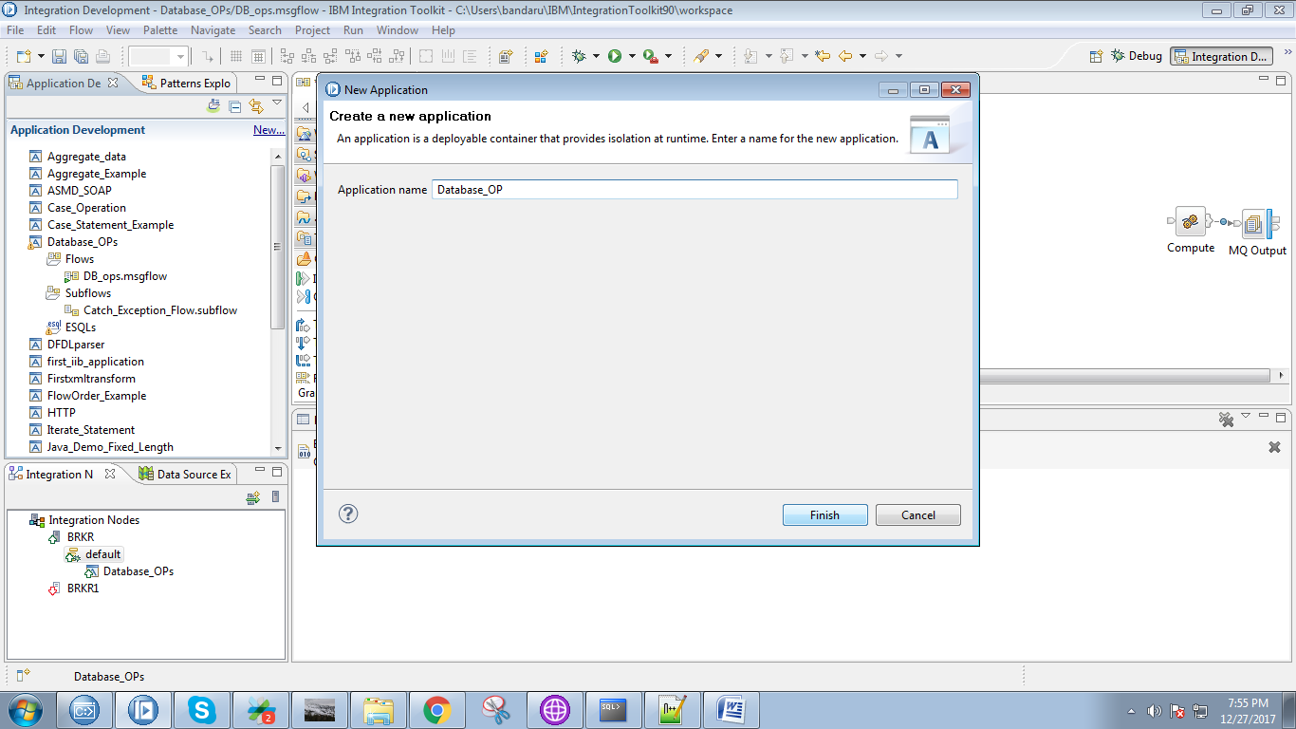

3. Under your application you able to see "New" click on it.

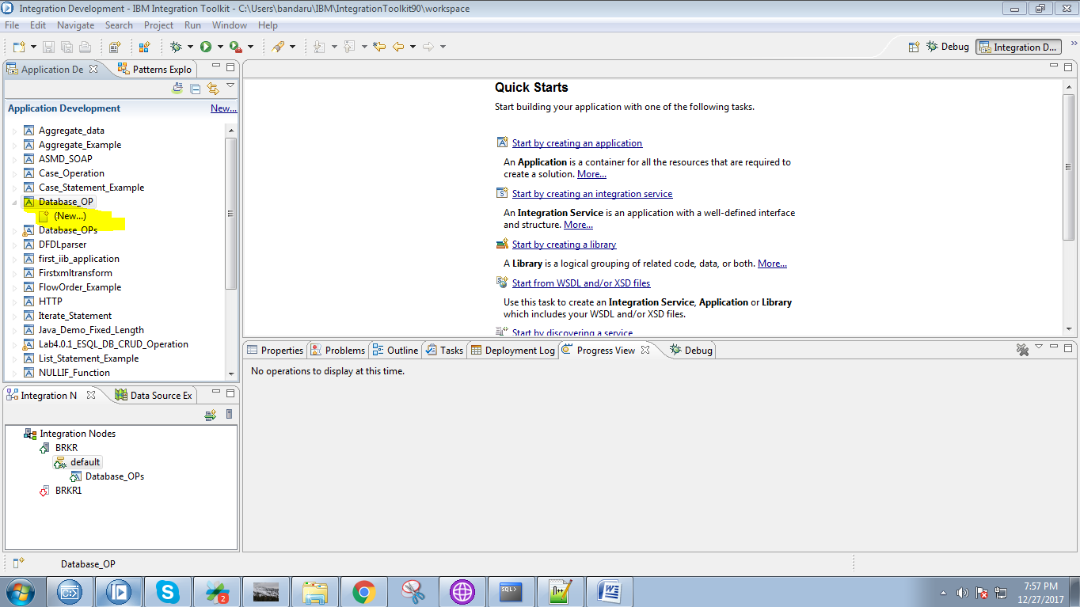

4. Select "Message Flow" from the given option.

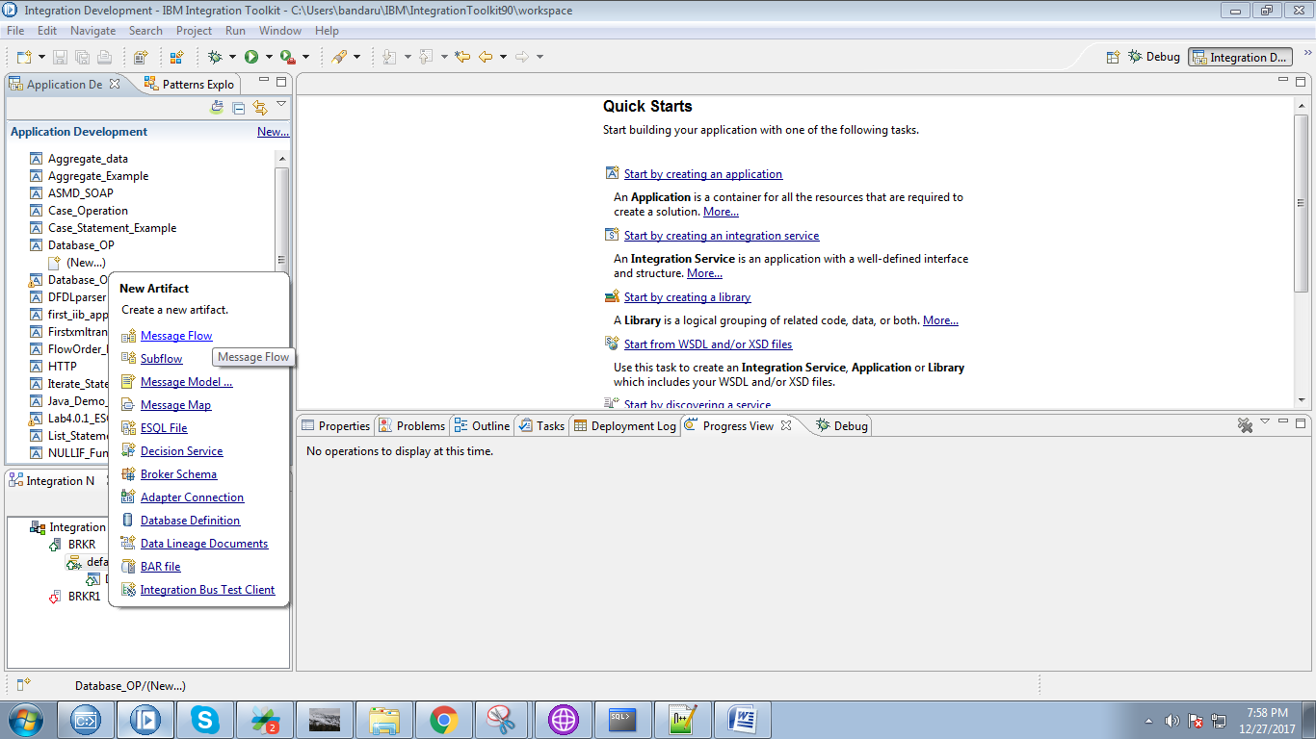

5. Give a name for your flow and click on "Finish" button.

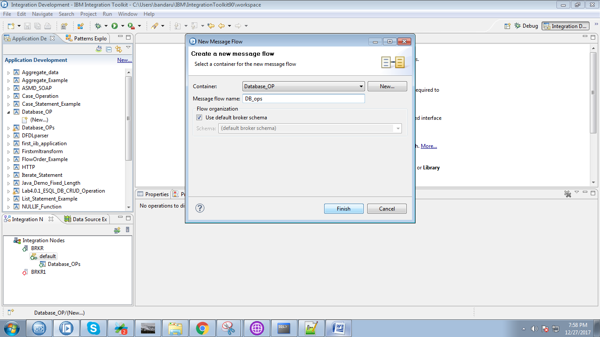

6. Drag "MQInput" from "WebSphere MQ" section and give it a name.

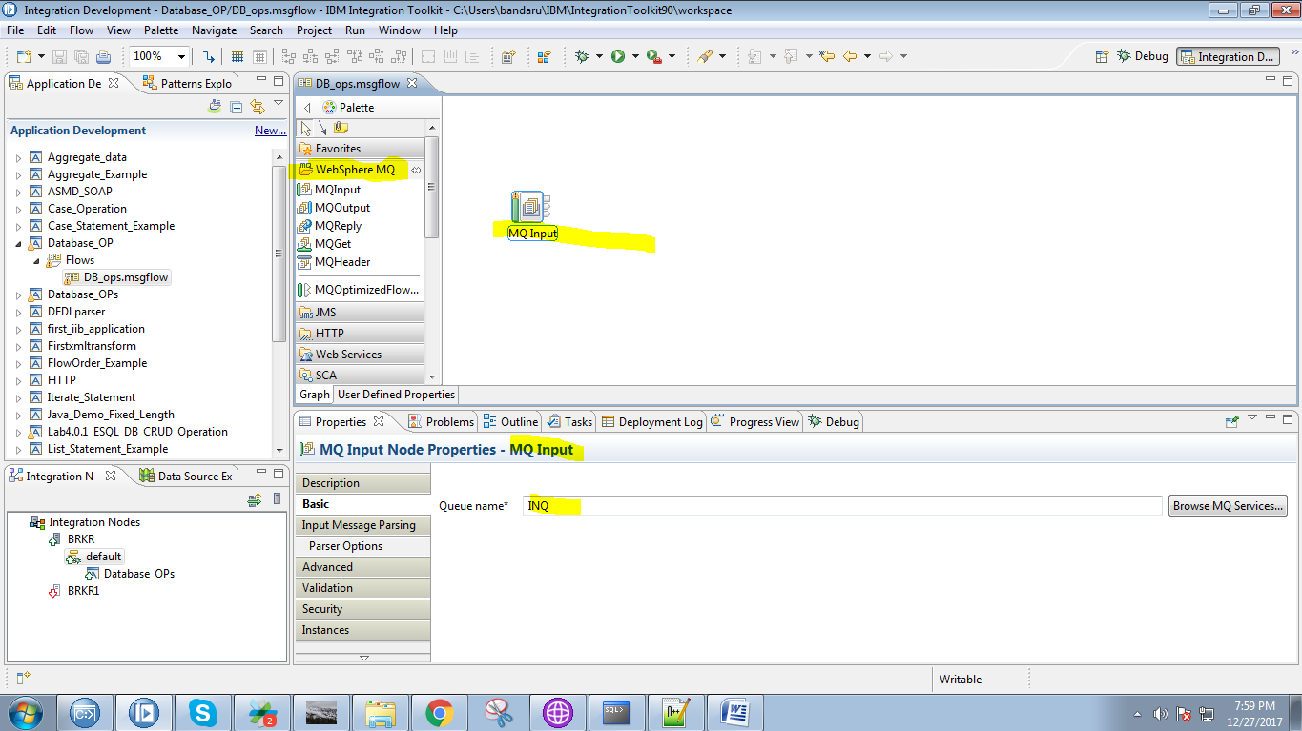

7. Drag "TryCatch" from "Constructor" section.

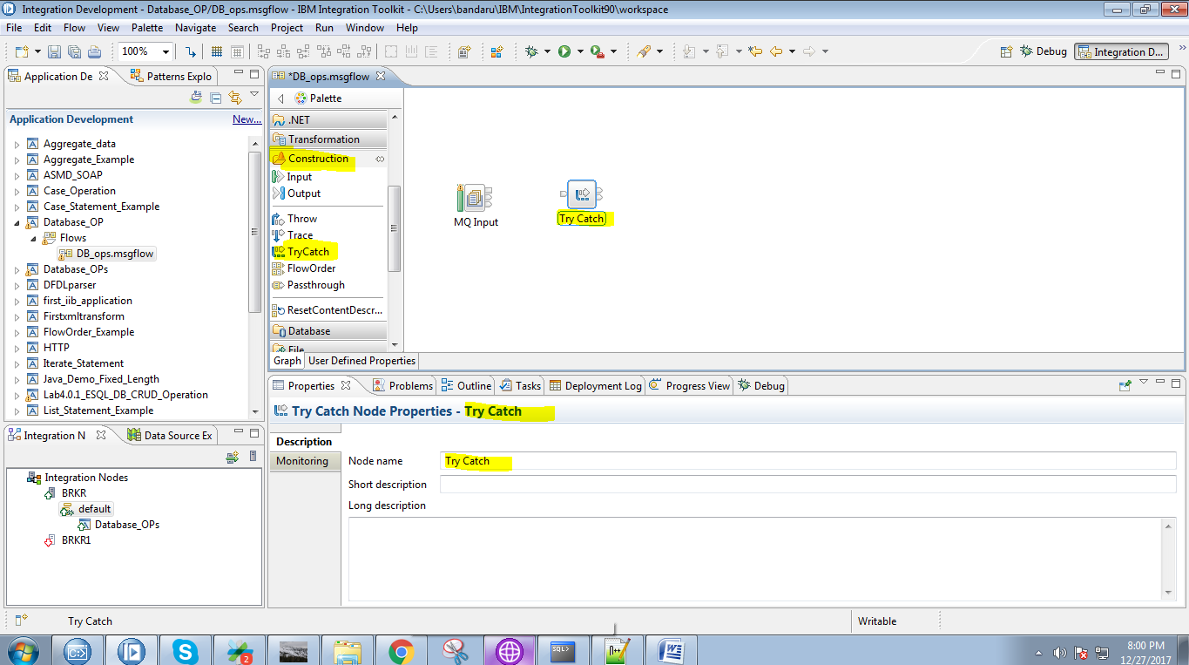

8. Connect "output" terminal of MQInput to "input" terminal of the TryCatch.

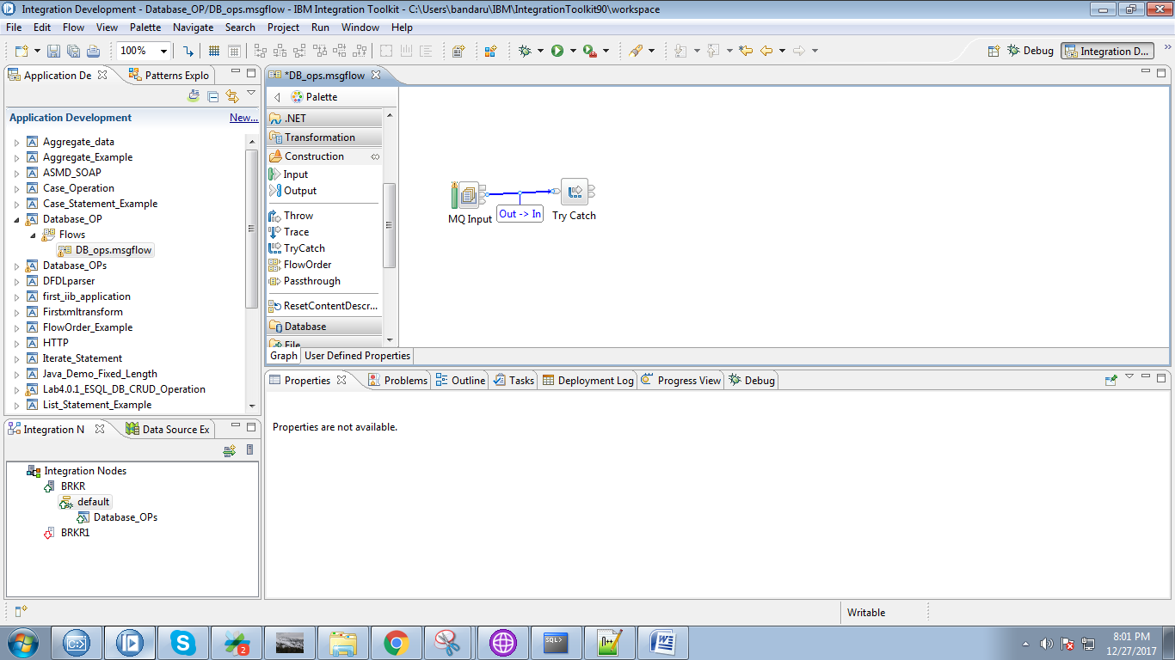

9. Drag "Compute" node from "Transformation" section.

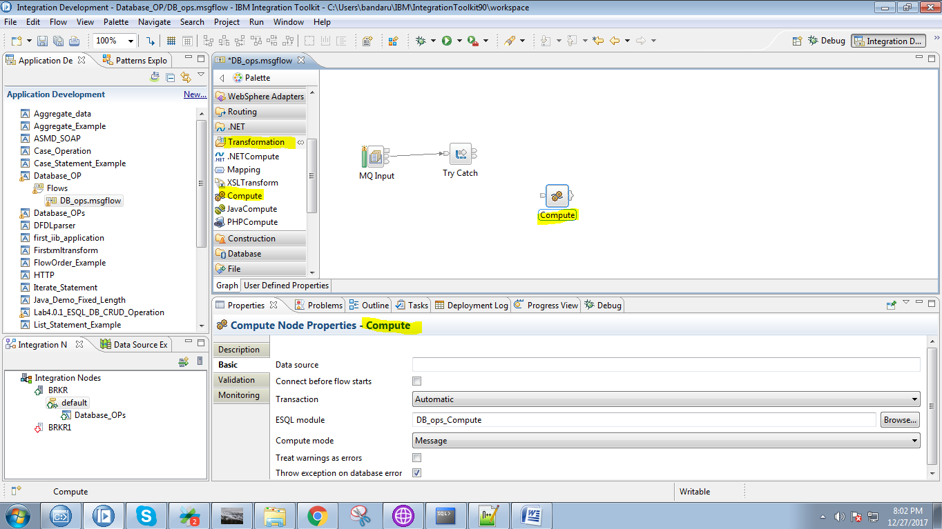

10. Connect "try" terminal of the TryCatch to "input" terminal of the compute node.

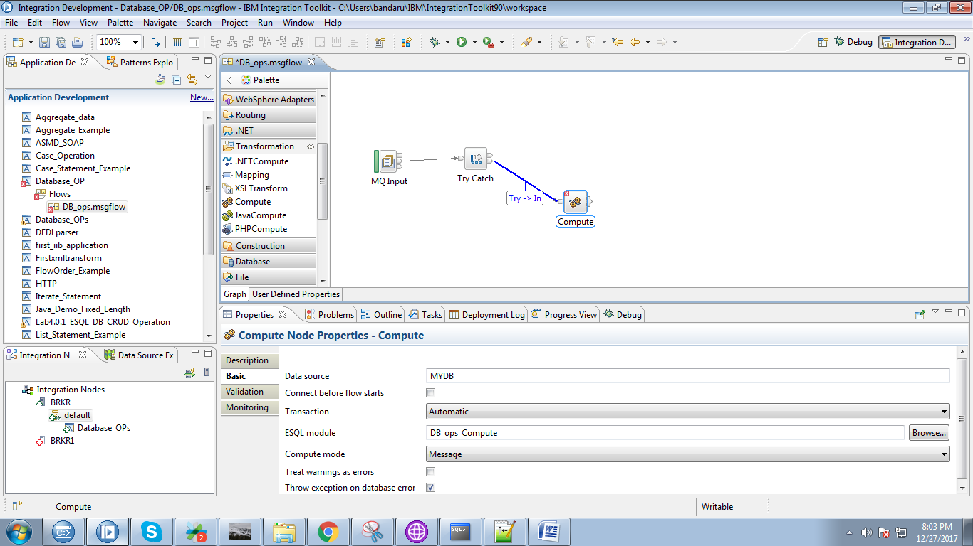

11. Give your data source name in compute node.

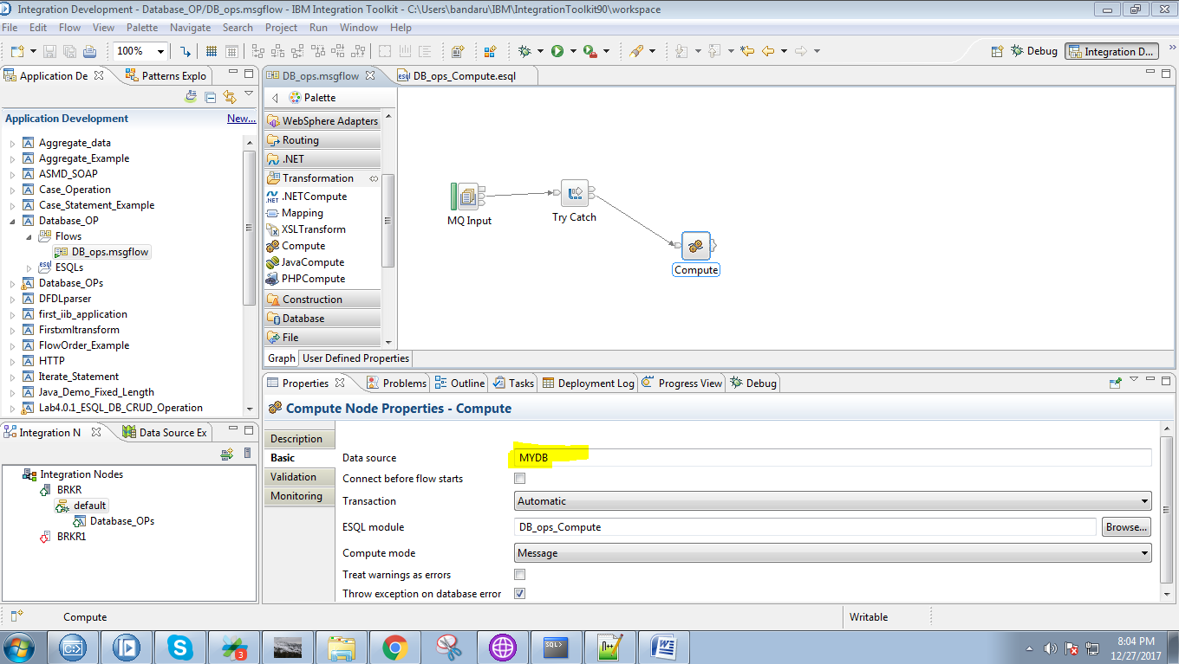

12. Drag "MQOutput" from the "WebSphere MQ" section and name the queue.

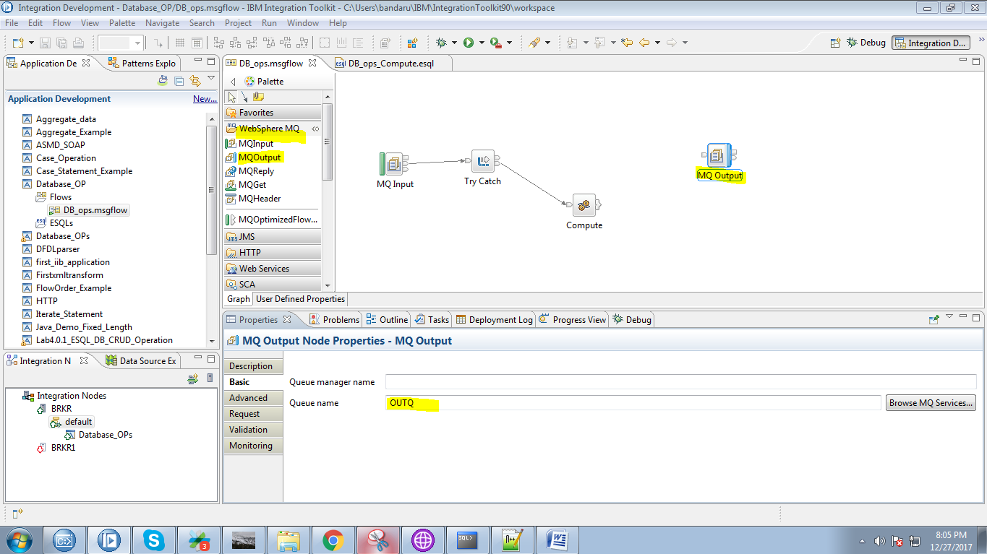

13. Click on output terminals of compute node and select "Out" and click on "OK" button.

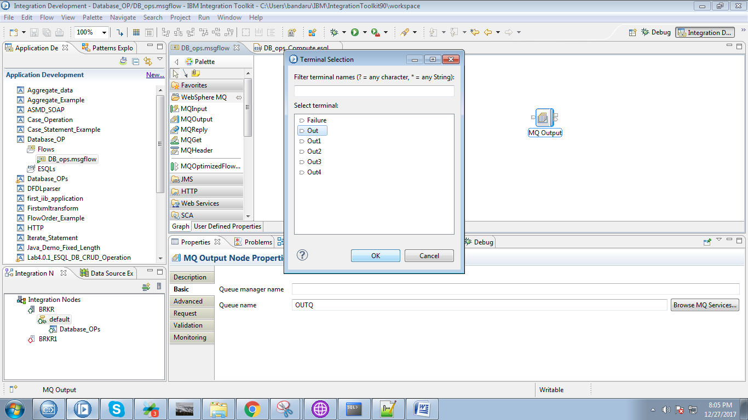

14. Connect "output" terminal of the compute node with "input" terminal of the MQOutput.

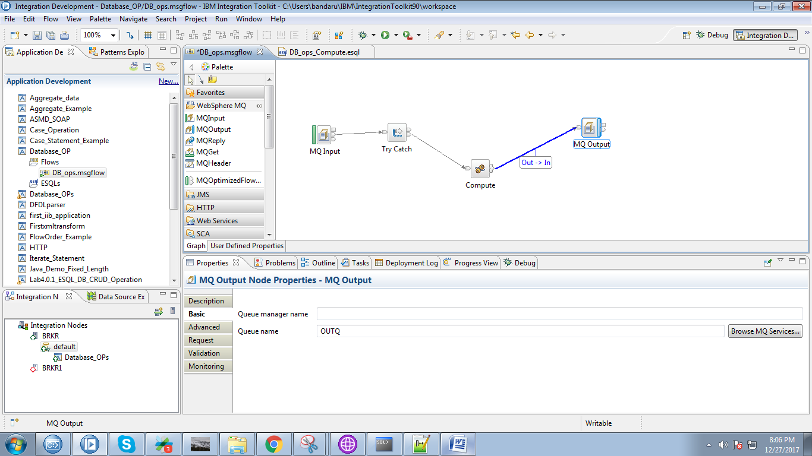

15. Double click on compute node and copy the following code.

Note: Database.<Oracle_userName>.<Table_Name>

CREATE COMPUTE MODULE DB_ops_Compute

CREATE FUNCTION Main() RETURNS BOOLEAN

BEGIN

-- CALL CopyMessageHeaders();

CALL CopyEntireMessage();

RETURN TRUE;

END;

CREATE PROCEDURE CopyMessageHeaders() BEGIN

DECLARE I INTEGER 1;

DECLARE J INTEGER;

SET J = CARDINALITY(InputRoot.*[]);

WHILE I < J DO

SET OutputRoot.*[I] = InputRoot.*[I];

SET I = I + 1;

END WHILE;

END;

CREATE PROCEDURE CopyEntireMessage() BEGIN

INSERT INTO Database.pradeep.CUSTOMERS VALUES(4,'Robin','Uthappa');

SET OutputRoot.XMLNSC.msg = 'record inserted successfully';

END;

END MODULE;

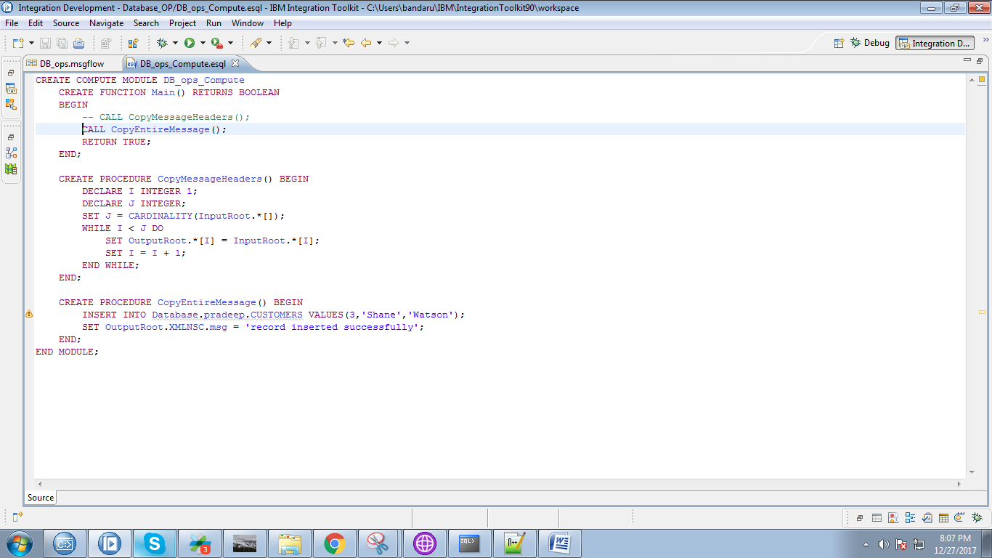

16. Right click on application and select "New"=>"Subflow"

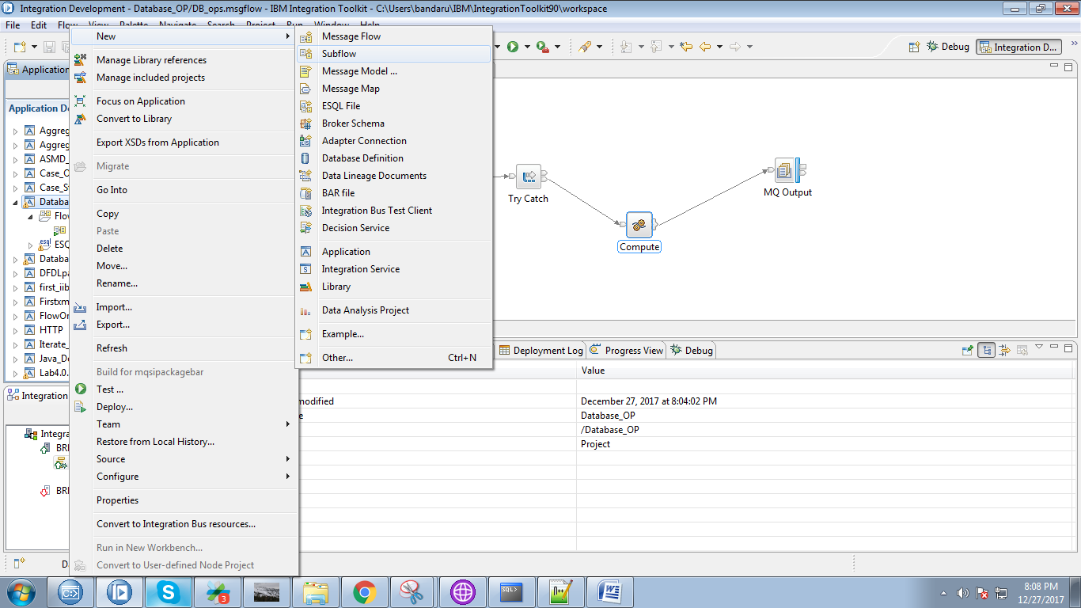

17. Give a name for your subflow and click on "Finish" button.

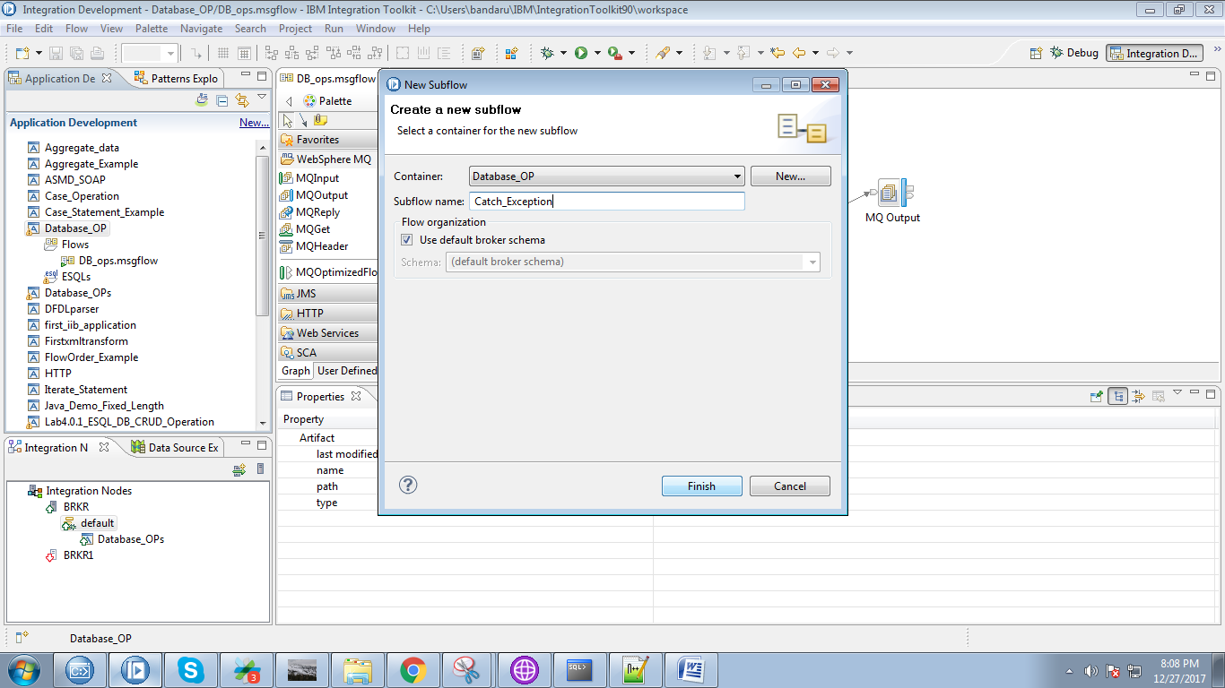

18. Drag the compute node on to subflow.

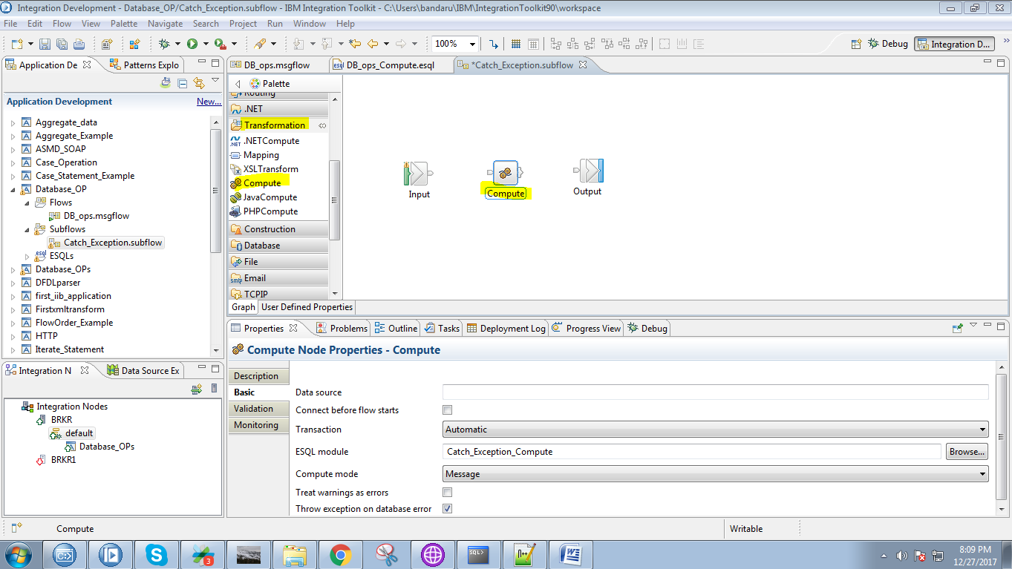

19. Connect "output" terminal of the in node to "input" terminal of the compute node.

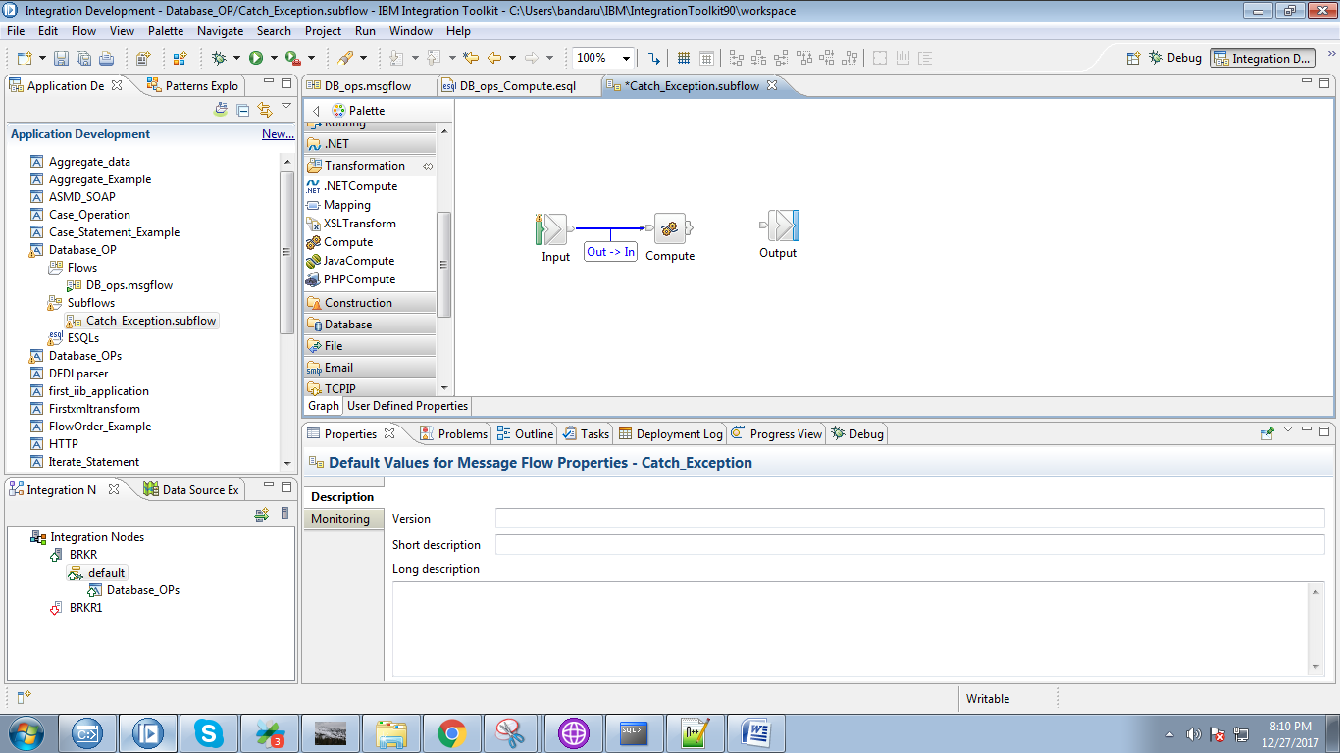

20. Click on output terminals of the compute node and select "Out" termianl and click on "OK" button.

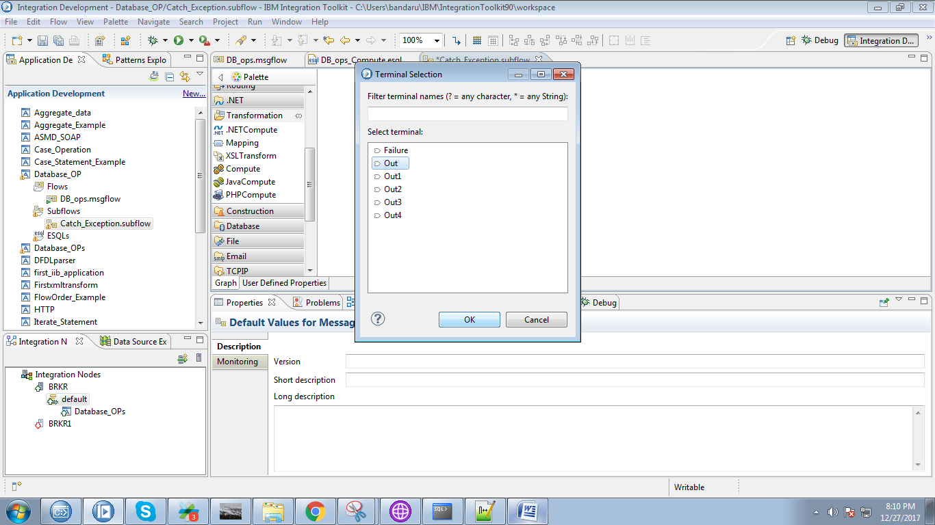

21. Connect "output" terminal of the compute node with "input" terminal of the output node.

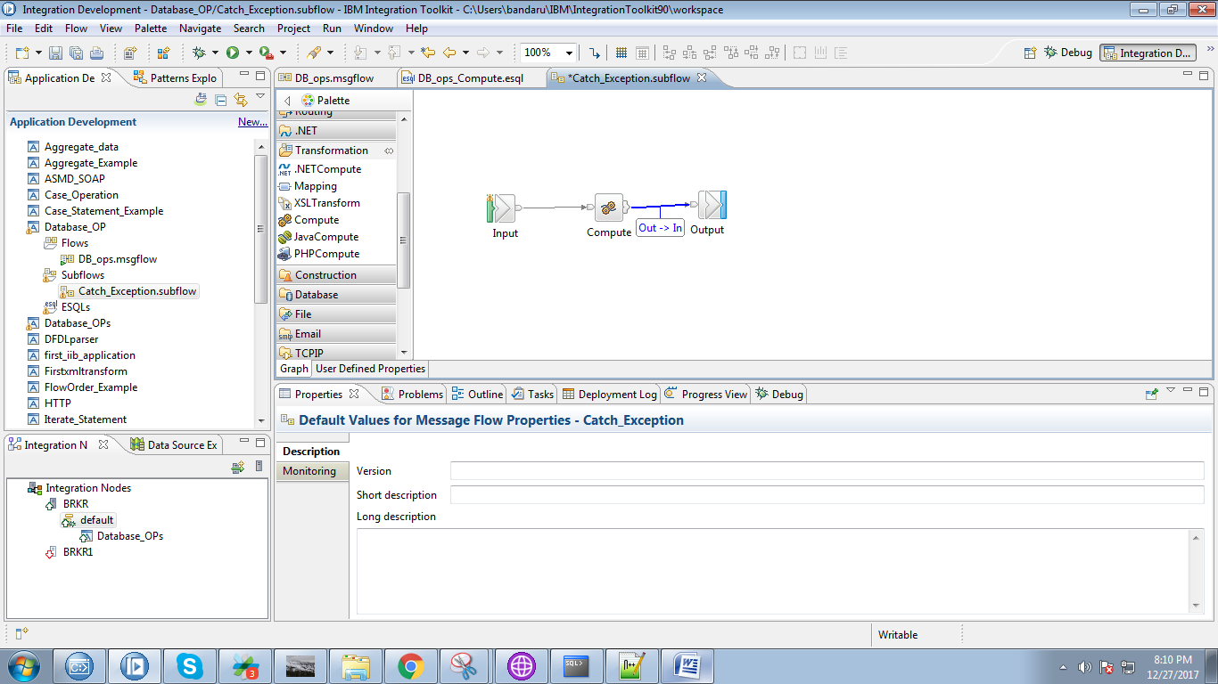

22. Copy the following code in to compute node.

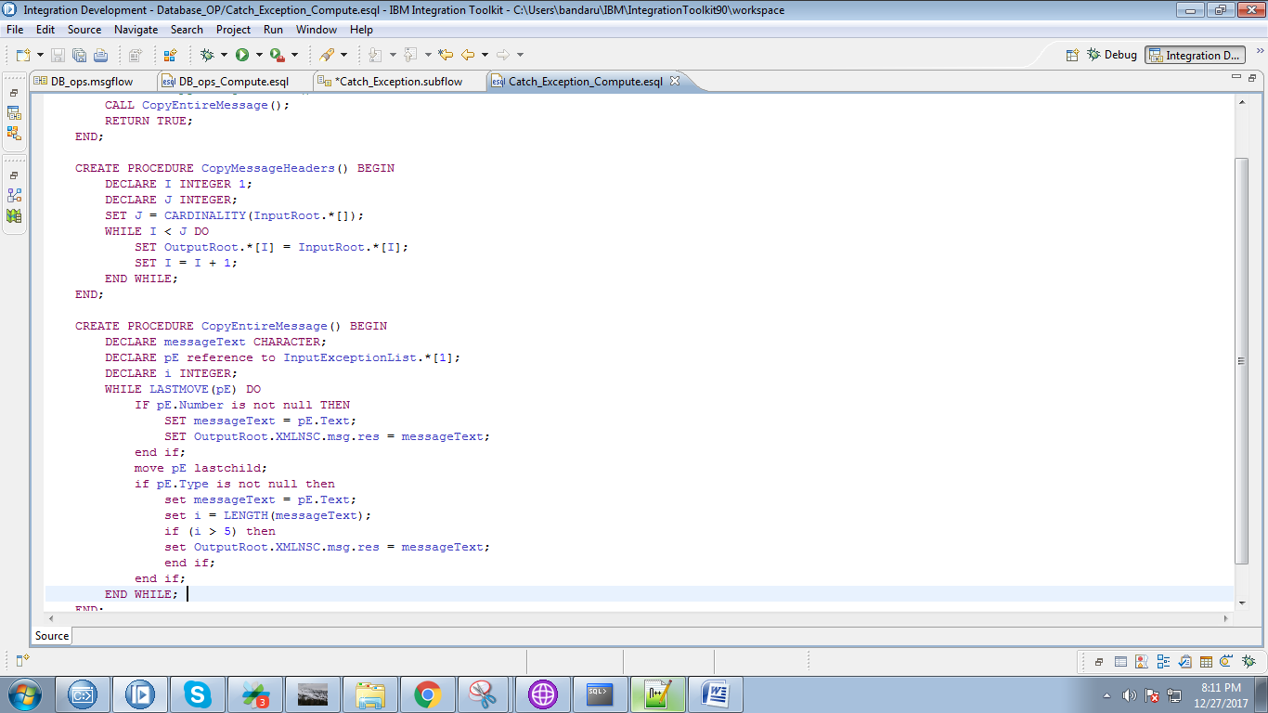

CREATE COMPUTE MODULE Catch_Exception_Compute

CREATE FUNCTION Main() RETURNS BOOLEAN

BEGIN

-- CALL CopyMessageHeaders();

CALL CopyEntireMessage();

RETURN TRUE;

END;

CREATE PROCEDURE CopyMessageHeaders() BEGIN

DECLARE I INTEGER 1;

DECLARE J INTEGER;

SET J = CARDINALITY(InputRoot.*[]);

WHILE I < J DO

SET OutputRoot.*[I] = InputRoot.*[I];

SET I = I + 1;

END WHILE;

END;

CREATE PROCEDURE CopyEntireMessage() BEGIN

DECLARE messageText CHARACTER;

DECLARE pE reference to InputExceptionList.*[1];

DECLARE i INTEGER;

WHILE LASTMOVE(pE) DO

IF pE.Number is not null THEN

SET messageText = pE.Text;

SET OutputRoot.XMLNSC.msg.res = messageText;

end if;

move pE lastchild;

if pE.Type is not null then

set messageText = pE.Text;

set i = LENGTH(messageText);

if (i > 5) then

set OutputRoot.XMLNSC.msg.res = messageText;

end if;

end if;

END WHILE;

END;

END MODULE;

23. Drag the sub flow on to the main flow a node will genetates which explains subflow.

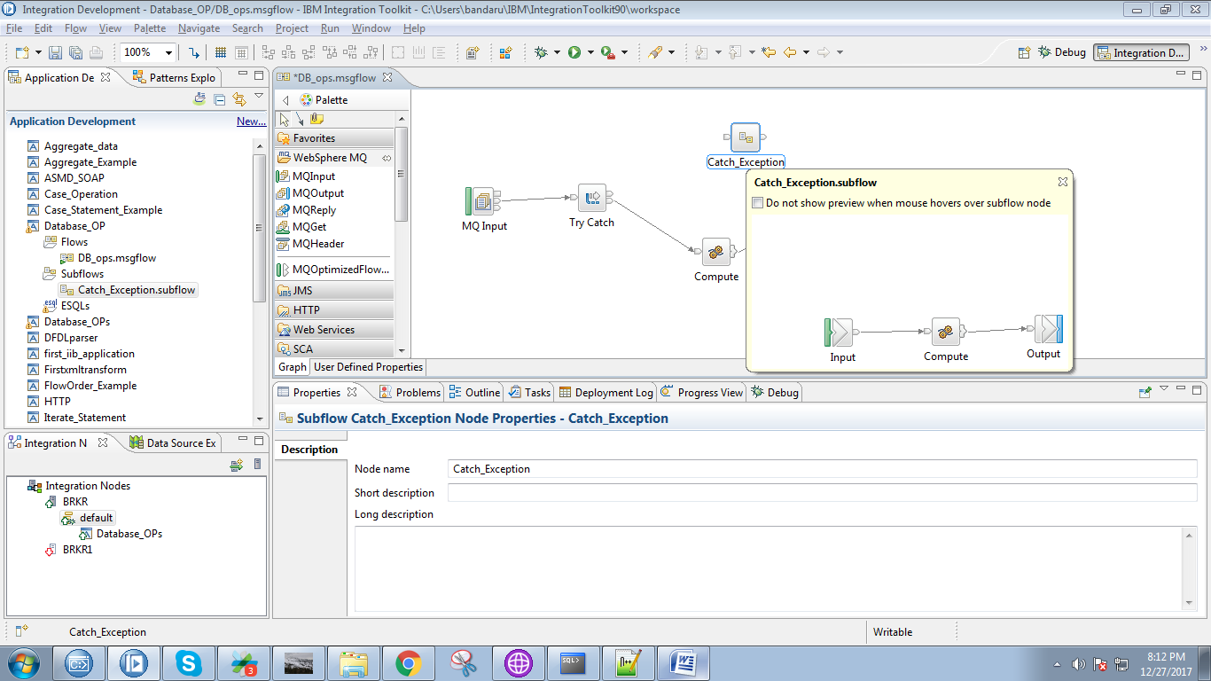

24. Connect "Catch" terminal of the TryCatch with the "input" terminal of the subflow node.

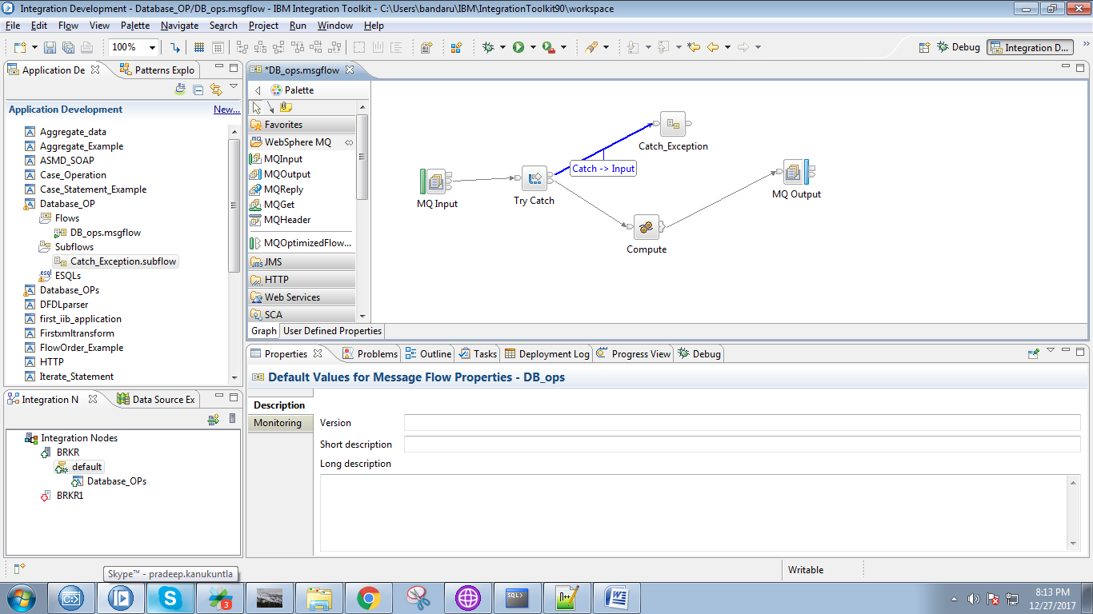

25. Connect "output" terminal of the subflow node with "input" terminal of the MQoutput.

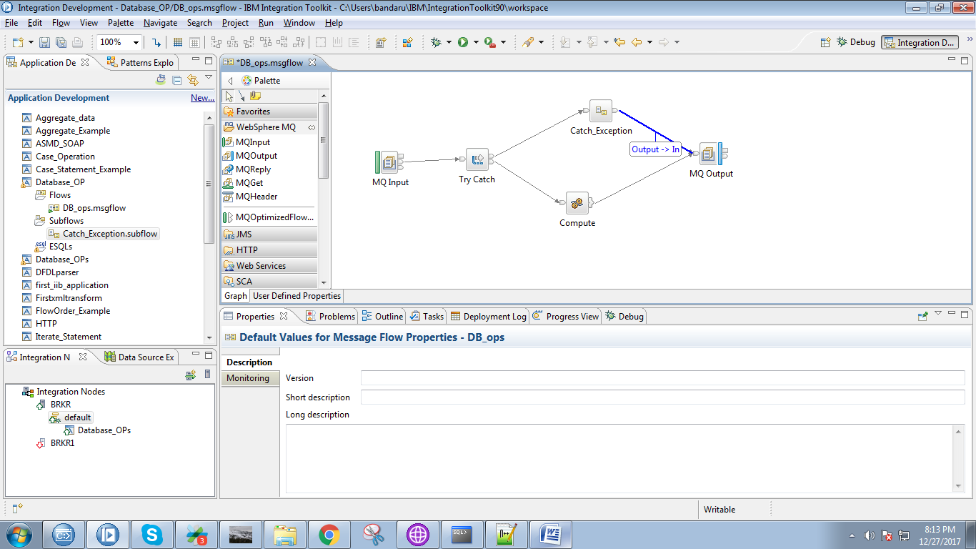

26. Right click on application and select "Deploy" option.

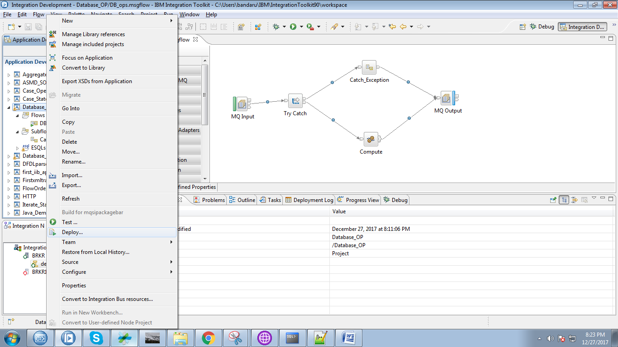

27. Select your broker and execution group and click on "Finish" button.

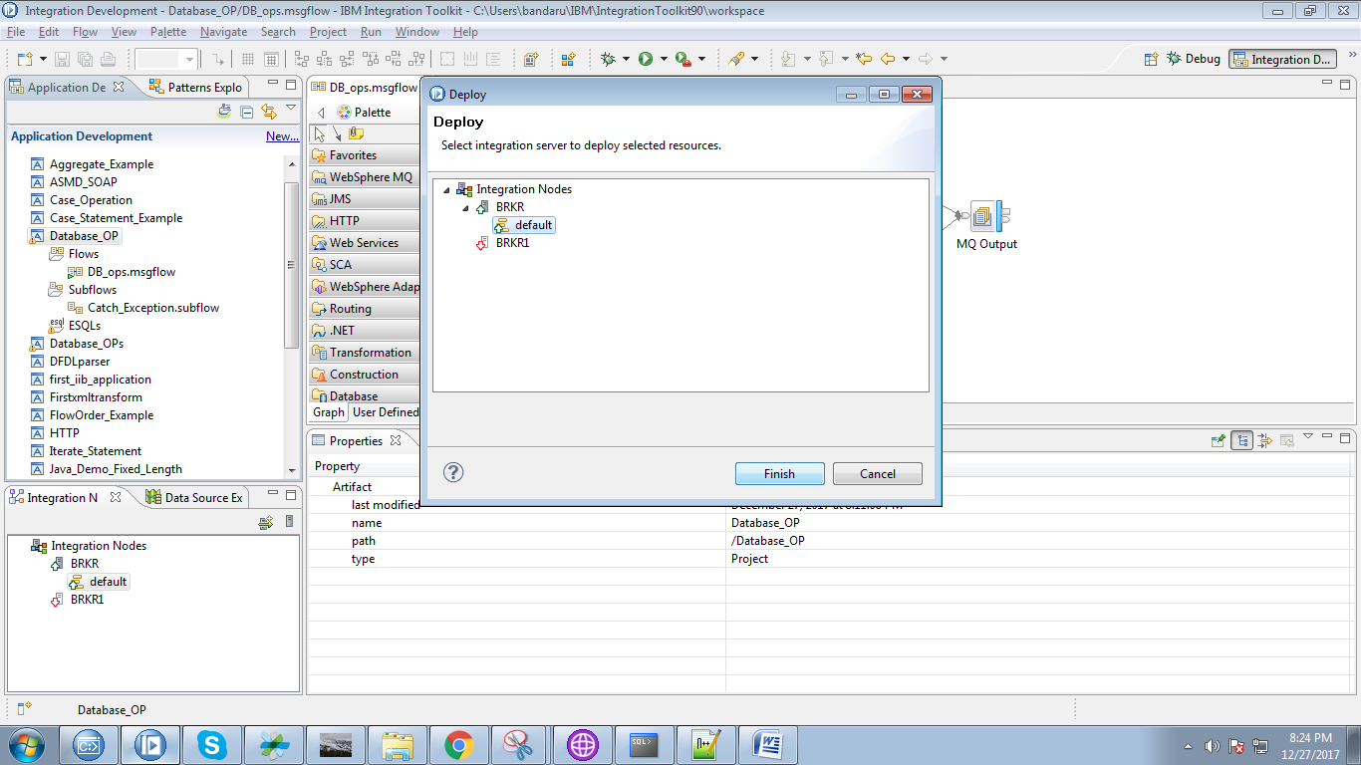

28. Create respectives queue in IBM WebSphere MQ Explorer.

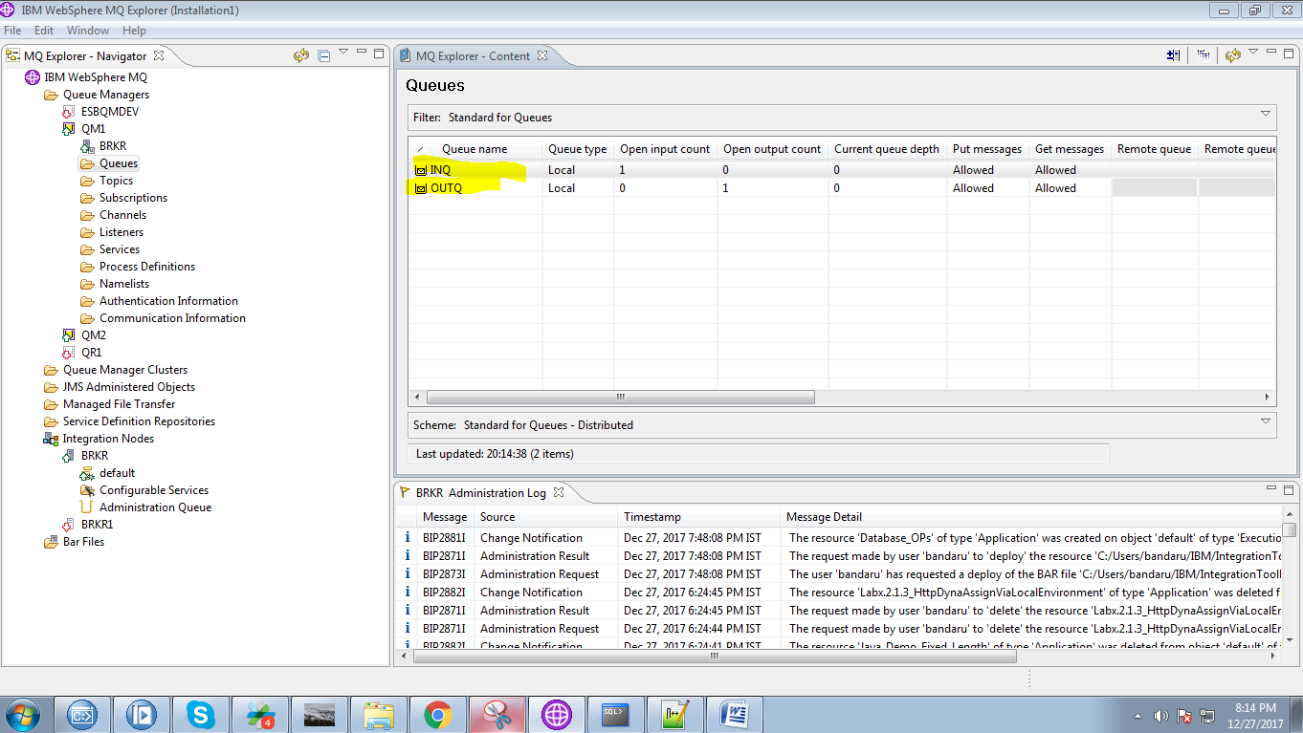

29. Right click on input queue and select "Put Text Message".

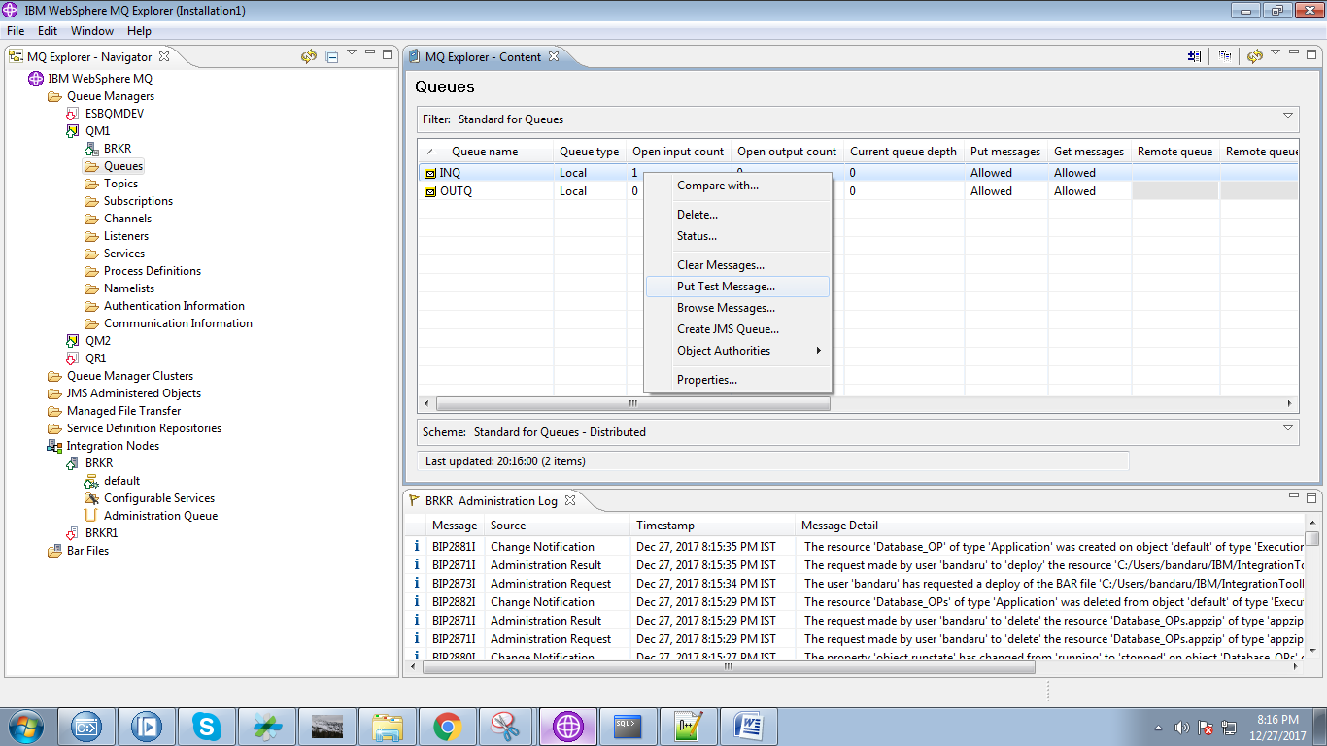

30. Place any dummy message and click "Put Message" button.

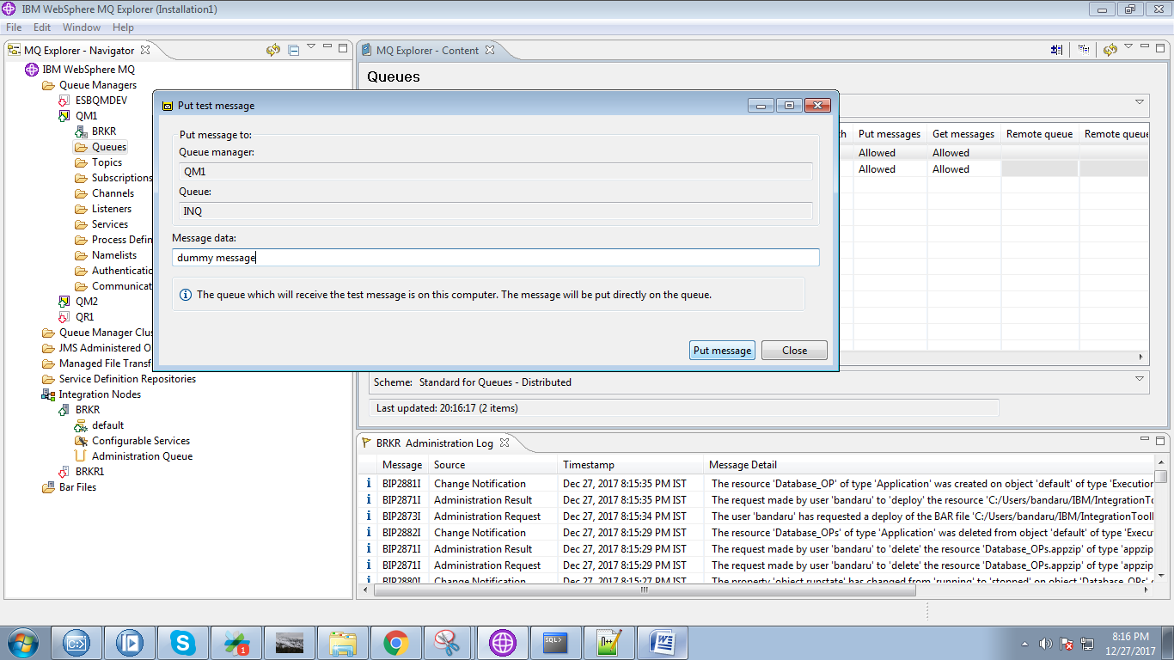

31. You can see output when you debug your flow.

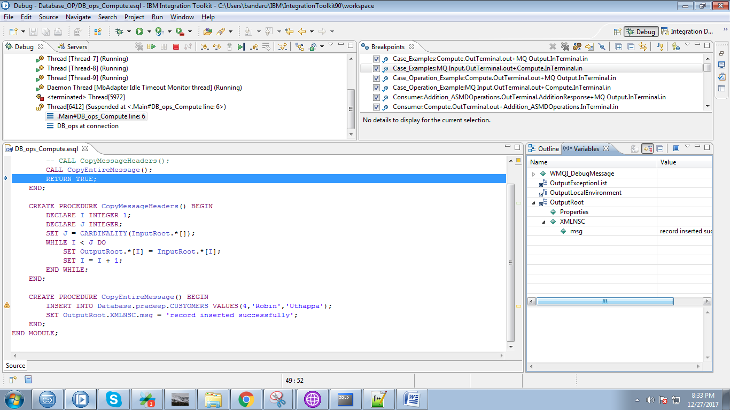

32. Output after compute node.

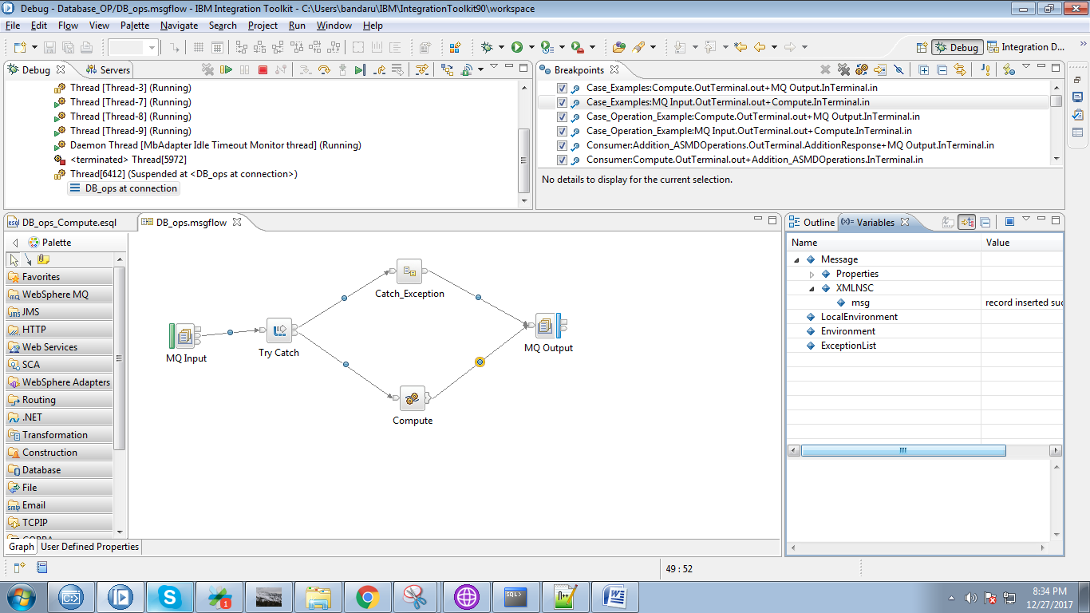

33. Select "OUTQ" and hit "Browse Q".

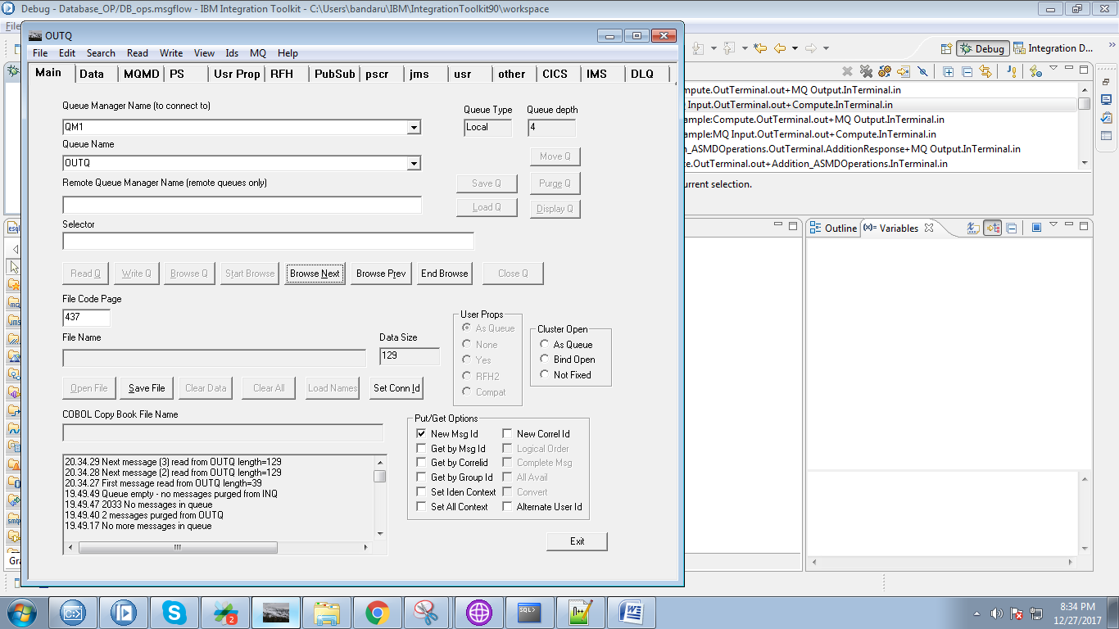

34. You can see result under "Data" tab.

